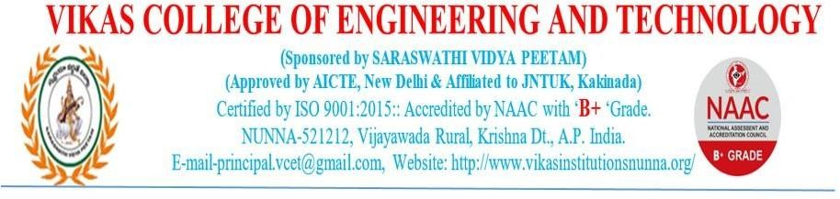

# 2.3.2 - Teachers use ICT enabled tools for effective teaching-learning process.

ICT tools are an integral part of the teaching learning process at Vikas College of Engineering and Technology. Teaching learning process becomes more effective through ICT facilities such as teaching concepts through animations, power point presentations and video lectures. Entire College Campus is Wi-Fi Enabled. All the classrooms, laboratory, seminar halls and auditorium are Wi-Fi/ICT enabled. ICT facilities available in the Institution includes projectors, computers, white screen and wi-fi hotspot access points.

Institute has procured ECAP learning management systems (LMS) for the use of teaching learning process during the lecture delivery. Course materials, Lesson Plan, Assignments and Midterm marks etc., are posted to the students through ECAP-LMS. ICT supported teaching learning processes are being practiced by all the faculty during their course delivery along with various innovative teaching methodologies. Faculties also upload their video lectures in YouTube to review the subject by the students after the class hours.

Digital library provides the access to various learning resources such as, DELNET, NSDL and Shodhganga. Through these digital plat forms students can access e-books, Journals, magazines and databases.

**ICT FACILITIES**

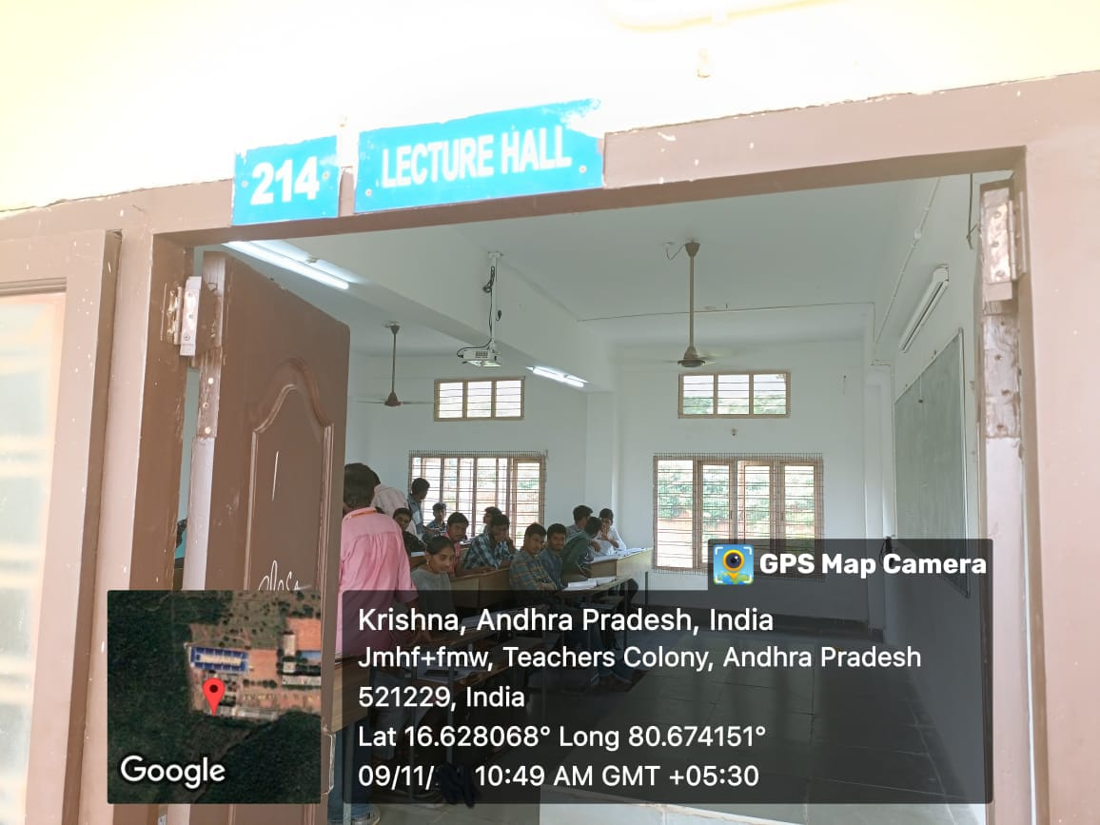

ECAP

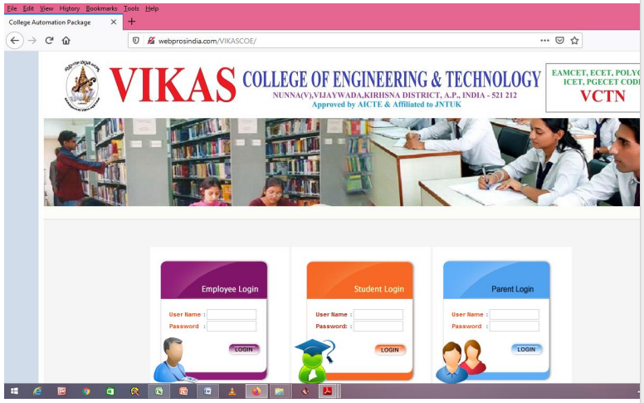

|  |  |  |
| --- | --- | --- |
| **Room number or Name of classrooms/Seminar Hall with LCD / wifi/LAN facilities** | **Type of ICT facility** | **Link to geo tagged photos** |
| 104 | LCD Projector/wifi | <https://vikasinstitutionsnunna.org/wp-content/uploads/2024/05/4.1.3.pdf-support.pdf-support.pdf> |
| 106 | LCD Projector/wifi |
| 110 | LCD Projector/wifi |
| 111 | LCD Projector/wifi |
| 112 | LCD Projector/wifi |
| 113 | WIFI |
| 116 | LCD Projector/wifi |
| 117 | LCD Projector/wifi |
| 118 | LCD Projector/wifi |
| 119 | LCD Projector/wifi |
| 208 | WIFI |
| 210 | LCD Projector/wifi |
| 213 | LCD Projector/wifi |
| 214 | LCD Projector/wifi |
| 215 | LCD Projector/wifi |
| 223 | WIFI |
| 224 | LCD Projector/wifi |
| 310 | LCD Projector/wifi |
| 311 | LCD Projector/wifi |
| 312 | LCD Projector/wifi |
| 315 | LCD Projector/wifi |
| 317 | LCD Projector/wifi |
| 318 | LCD Projector/wifi |
| 321 | LCD Projector/wifi |
| 322 | LCD Projector/wifi |
| 323 | LCD Projector/wifi |
| G03 | LCD Projector/wifi |

**SEMINAR HALL**

# SEMINAR TOPIC : - CHALLENGES INTRADITIONAL AND SOFTWARE DEVELOPMENT

# DATE:-27/01/24

# E:\data 3\anusha staff\NAAC -NQ -2\23-24\WhatsApp Image 2024-11-26 at 8.36.32 PM.jpeg

**ECAP BILL**

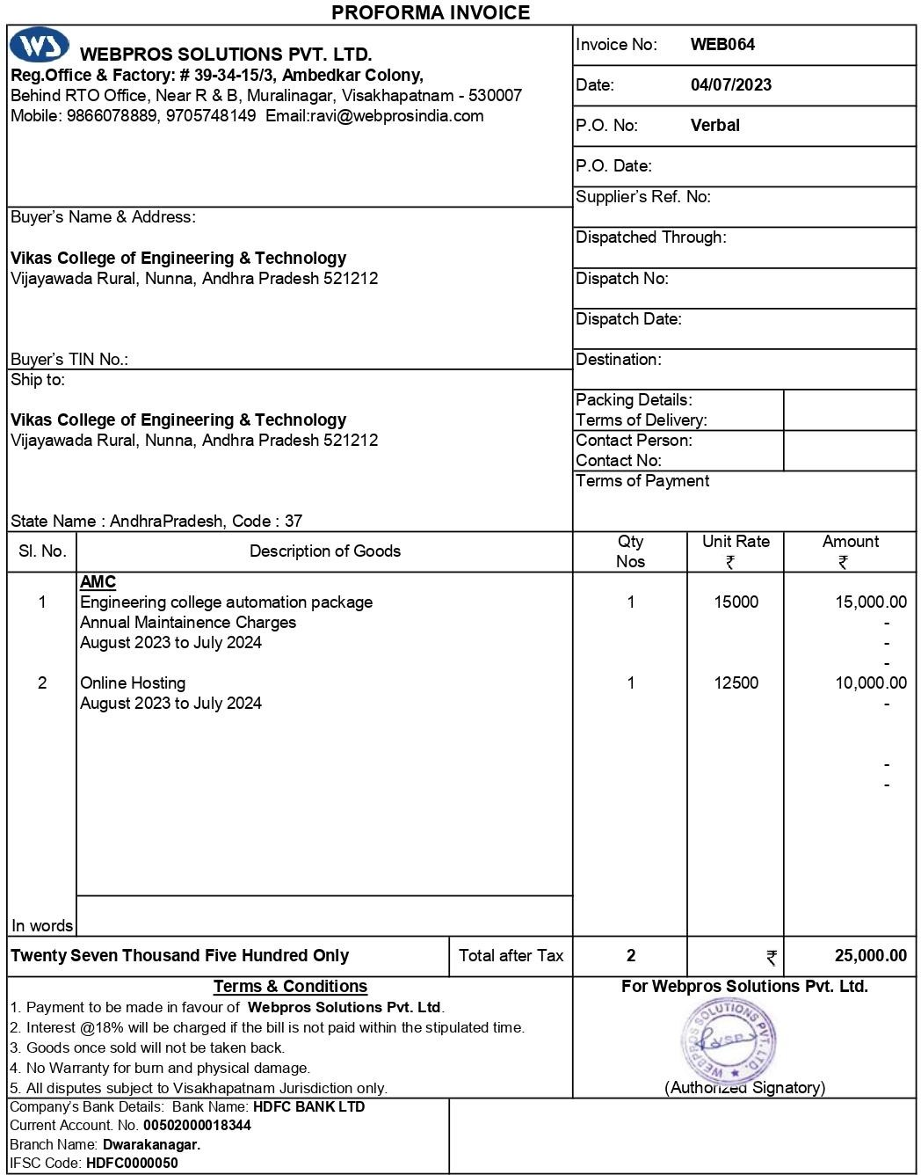

WIFI BILL

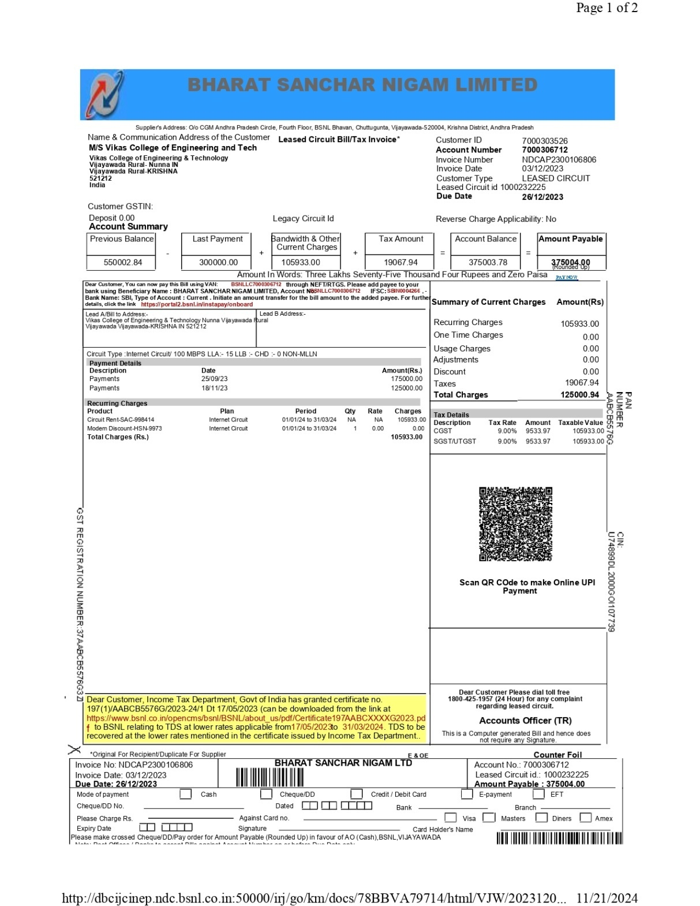

# DELNET

# 

**DIGITAL LIBRARY**

