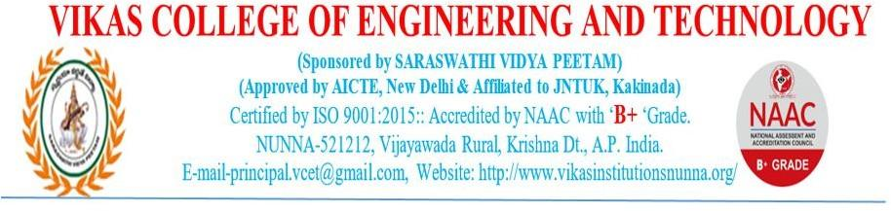**GOVERNANCE, LEADERSHIP AND MANAGEMENT**

**6.1 Institutional Vision and Leadership**

**6.1.1- The governance of the institution is reflective of and in tune with the vision and mission of the institution**

**Vision**

To be a premier educational institution for knowledge and skill development.

**Mission**

* Inculcate self-learning abilities and impart value based education:
* Promote knowledge sharing and innovation with mutual partnerships.
* Involve in activities and training for the overall development of the stakeholders.
* Provide an ambiance conducive for building engineers, entrepreneurs and administrators.
* Inspire and make the rural youth ready for the competitive world with values and ethics.

**Quality Policy**

Our quality policy is to impart value-based education and strives for continuous improvement by adopting modern training methodologies with quality infrastructure and human resources that meet the needs of society.

**Perspective Plan**

Vikas College of Engineering and Technology was established in the year 2008 by Saraswathi Vidya Peetam with the goal of imparting quality technical education to rural students, Institute has state-of-the-art infrastructure and experienced faculty to produce top-notch technocrats. The Institute is governed by the governing council consisting of management members, Principal, Faculty representative, eminent academic and industrial experts, Institute has various committees/clubs/cells that consists of both internal and external stakeholders for the implementation of its strategic plans in achieving academic excellence. A well-established organizational structure ensures smooth flow of work and communication across all levels for the effective implementation of strategic-plans.