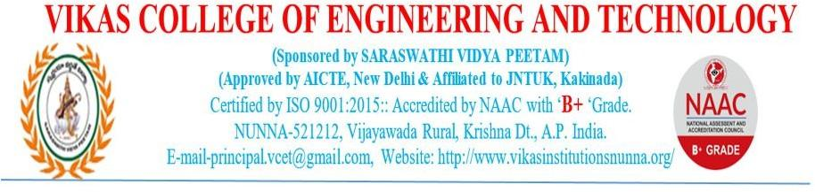

**6.1.2 The effective leadership is visible in various institutional practices such as decentralization and participative management.**

Vikas College of Engineering and Technology adopts a progressive approach to governance, emphasizing decentralized decision-making and participative management. This philosophy is upheld by two key committees: the Governing Body and the College Academic Committee, which convene regularly to ensure the smooth functioning of the institution. The college empowers institutional hierarchy at all levels authorizing stakeholders to participate in the decision making at their respective levels. The administration constitutes councils and committees consisting of Management, Principal, HoDs, faculties, staff, students, alumni and various other internal and external stakeholders to carry out various academic, co-curricular and extracurricular activities.

Feedback from stakeholders is actively solicited and utilized for continuous improvement processes. Examinations are decentralized and managed by a dedicated Examination Cell, while the Placement and Training Cell operates under the guidance of a Placement Director/Officer, in collaboration with departmental placement coordinators.

The preparation of the Academic Calendar involves collaboration between the Principal, HoDs. committee coordinators, and other key personnel, ensuring alignment with the schedule provided by the JNTUK University. The Academic Calendar covers a range of activities. including working days, holidays, institutional events, examinations, symposiums, industrial visits, placement training sessions, faculty development programs, seminars, workshops. conferences, and internal quality assurance audits.